Nithin S
221IT085

IT150 Lab Assignment 2

1. 1.Write a C++ program to display the details of the below figure. Use the concept of different types of
inheritance techniques to implement the same.

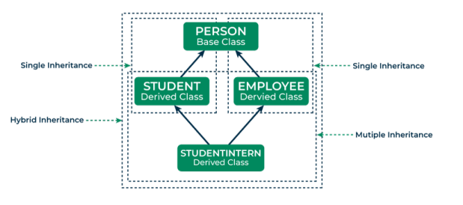

CODE

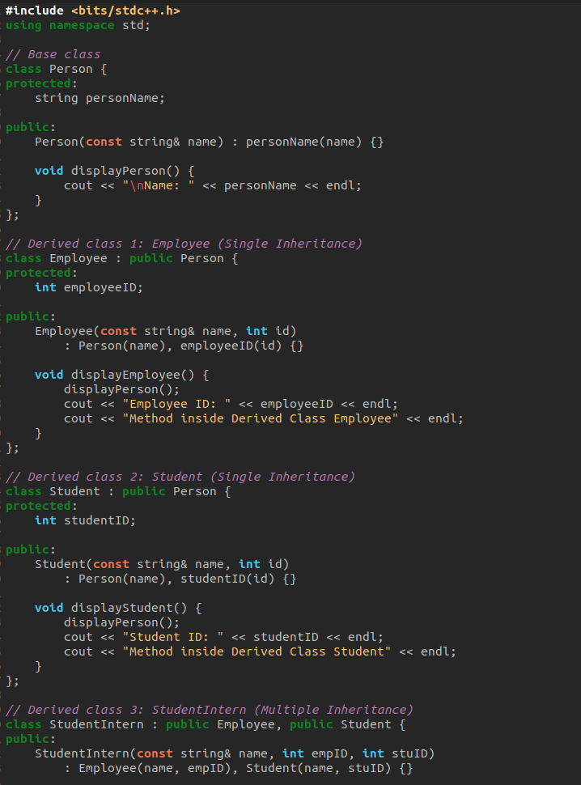

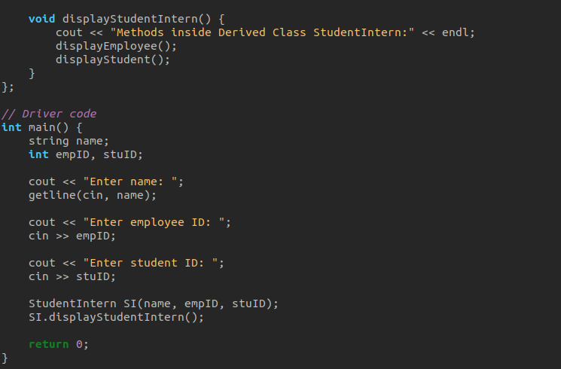

OUTPUT

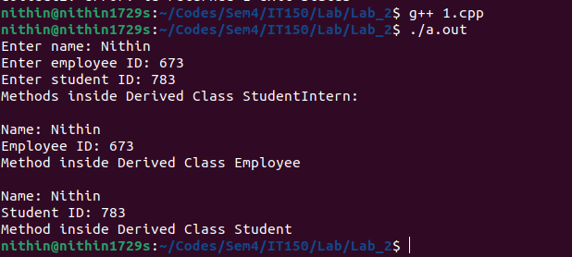

Explanation:

Inheritance: The Employee and Student classes inherit from the Person class, demonstrating single inheritance. This means that both Employee and Student inherit the attributes and methods of the Person class.

Single Inheritance: Both Employee and Student are derived from the Person base class, acquiring its member variables and functions, such as displayPerson(). This promotes code reusability by allowing the derived classes to use or override the common functionality defined in the base class.

Multiple Inheritance: The StudentIntern class showcases multiple inheritance by inheriting from both Employee and Student classes. This class combines features from both parent classes, emphasizing flexibility in designing class hierarchies.

2. Write a C++ program to display the details in the below figure. Use hierarical and multilevel techniques to implement the same.

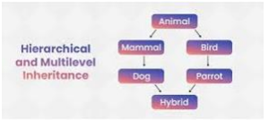

CODE

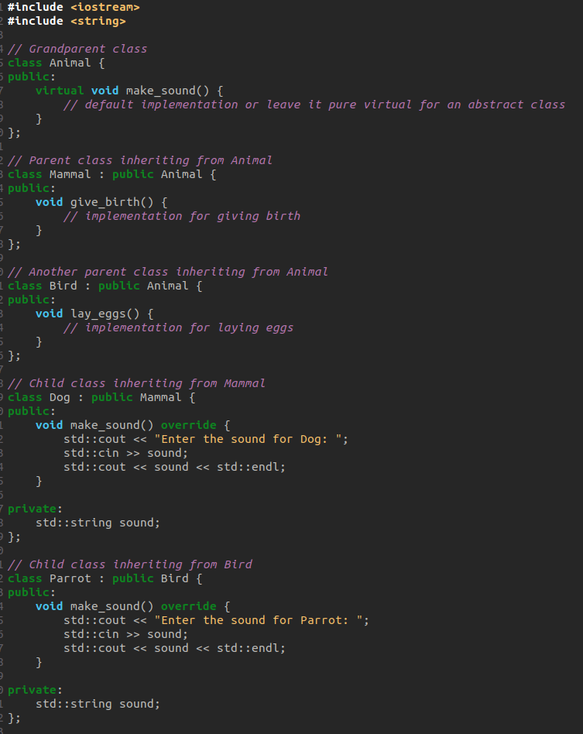
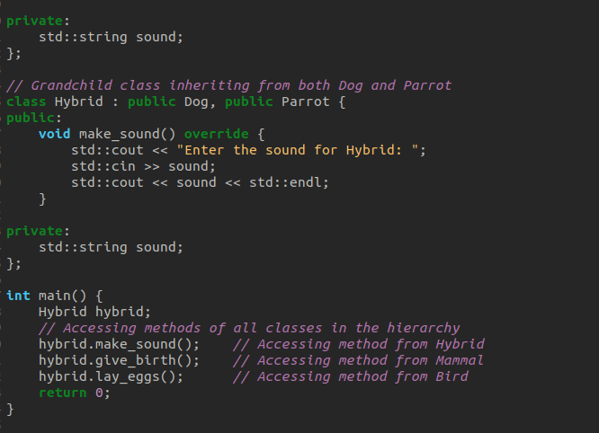

OUTPUT

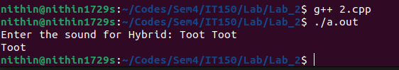
Explanation:

Animals serve as the grandparent class.
Mammal and Bird are parent classes, both directly inheriting from Animal.
Dog is a child class inheriting from Mammal.
Parrot is a child class inheriting from Bird.
Hybrid is a grandchild class inheriting from both Dog and Parrot.
Here’s how the inheritance works:
Mammal and Bird classes form a hierarchical inheritance, as they both inherit directly from Animal.
Dog and Parrot classes represent multilevel inheritance, inheriting from Mammal and Bird respectively.
Hybrid class demonstrates a combination of multilevel and hierarchical inheritance by inheriting from both Dog and Parrot.

3. 3. Derive a child class from the base class in different access modes. Write a C++ Program to show access
to Private, Public and Protected using Inheritance for the following 3 cases:
a) Derived Class is inheriting the Base Class publicly
b) Derived Class is inheriting the Base Class protectedly
c) Derived Class is inheriting the Base Class privately

CODE

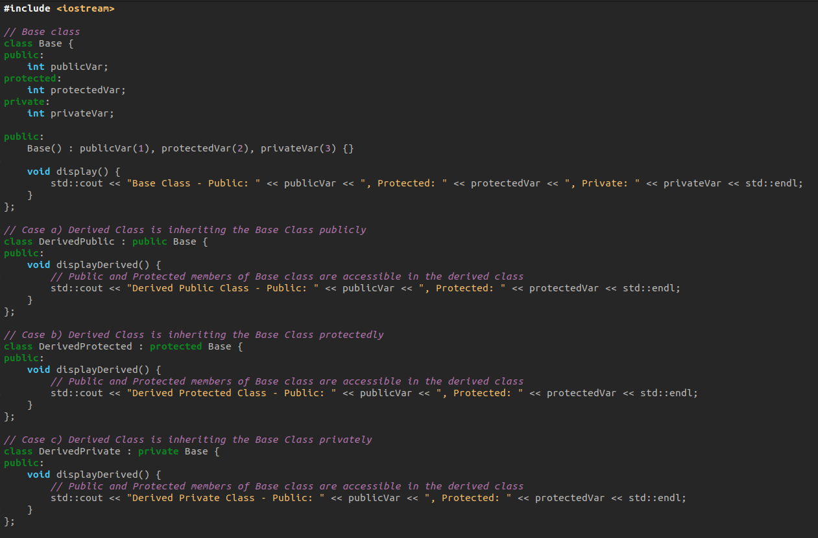

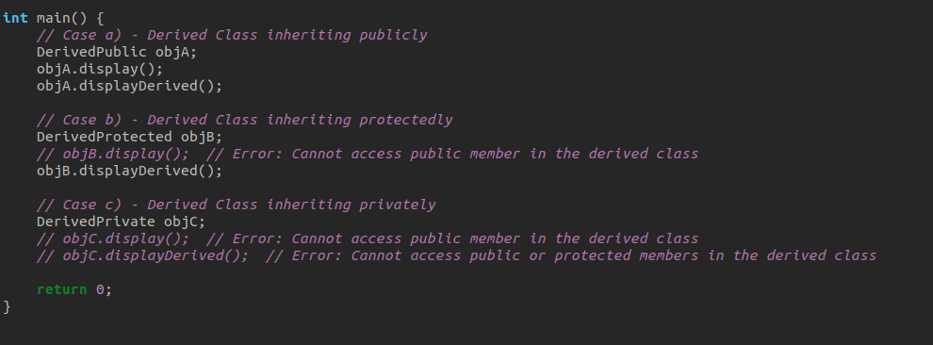

OUTPUT



Explanation:

The Base class has three member variables: publicVar, protectedVar, and privateVar with different access specifiers.

Three derived classes (DerivedPublic, DerivedProtected, DerivedPrivate) inherit from Base class with different access modes.

In the main function, instances of each derived class are created to demonstrate the access to base class members in each case.

The display method of the base class is used to show the access to the members in each derived class. Note that in cases b) and c), accessing the public member directly in the derived class results in an error, but the derived class can still access it through its member functions.

